IT 2045C Computer Programming II
Prof. Tom Wulf
Lab 07B: Software Engineering Camp Part B: Tic Tac Toe
Fall 2024 v1
20 pts

This is the second in a series of sub-assignments in which we will practice the software engineering process presented here.
For each project we will:
- Derive a candidate class list from, requirements documents, Use-Cases. And subject matter knowledge
- Create CRC cards for the candidate classes and cull the unneeded classes
- Create a UML diagram showing the relationships between the classes in our design
- Implement our classes and create JUnit tests for them. (Note that we may not create the complete applications here for each case study and then we only stub out the methods in the classes to create a test first Agile software engineering approach.

Part B: OOP Tic Tac Toe

Previously, we coded a Swing GUI version of Tic Tac Toe by grafting a GUI onto console code that was developed in CP I. From an engineering perspective this was pretty ugly. We ended up putting most of the game logic code into the ActionListener for the Tic Tac Toe button.
What I want you to do here is to completely re-engineer TicTacToe using the Software Engineering approach we have been exploring.

- Using the requirements documents and general background business knowledge, we create a list of candidate classes for our application. Here for Tic Tac Toe, we are pretty familiar with the internals so consider:
  - Do we need a Game class?
  - Do we need a Board class i.e. TTTBoard? Consider that we have a bunch of static methods that all use the Board. These would belong to a Board object…
  - Should we subclass JFrame or give the Game a JFrame instance?
  - You should use the sub-classed TTTTileButton from Ass 01!
Put your list here with candidate class names one per line.
TicTacToeRunner
TicTacToeFrame
TTTGame
TTTBoard
TicTacToeTile
TileListener (inner class of TicTacToeFrame)
Player
Move
ScoreBoard
Cell / Square

Design decisions:
a. Game class: Yes. TTTGame holds the rules (whose turn it is, move count, win/tie checks) so the ActionListener no longer contains game logic.
b. Board class: Yes. TTTBoard owns the 3x3 array, and the old static helpers (clearBoard, isValidMove, isWin, isRowWin, isColWin, isDiagonalWin, isTie) become its instance methods.
c. JFrame: TicTacToeFrame subclasses JFrame and has a TTTGame instance. This keeps the game logic free of Swing code, so TTTGame and TTTBoard can be unit tested.
d. TicTacToeTile: Reused unchanged from the original GUI TTT. It extends JButton and stores its row and column.
- Now, create the CRC cards for each class noting the class name, class responsibilities, and any collaborators. At this point, you can cull the classes from the candidate list that you do not use. LEAVE THEM IN THE LIST BUT USE THE STRIKETHROUGH FONT TO SHOW THEY ARE ELIMINATED.
Put the CRC cards here for the classes:

Class: TicTacToeRunner
Responsibilities  • Start the application  • Create the TicTacToeFrame on the Swing event thread | Collaborators  TicTacToeFrame

Class: TicTacToeFrame (extends JFrame)
Responsibilities  • Build the window: status label, 3x3 grid of tiles, Quit button  • Show the player's mark on the tile  • Show illegal move / win / tie messages  • Ask to play again; reset the tiles or exit  • Confirm before quitting | Collaborators  TTTGame  TicTacToeTile  TileListener  JOptionPane

Class: TileListener (inner class, implements ActionListener)
Responsibilities  • Handle a click on any tile  • Pass the tile's row and column to TTTGame.makeMove()  • Tell the frame what to show based on the result | Collaborators  TicTacToeFrame  TicTacToeTile  TTTGame

Class: TTTGame
Responsibilities  • Track the current player (X goes first)  • Track the move count  • Apply a move to the board and report the result (INVALID, CONTINUE, WIN, TIE)  • Switch players after each valid move  • Reset for a new game | Collaborators  TTTBoard

Class: TTTBoard
Responsibilities  • Store the 3x3 grid of marks  • Clear the board  • Validate a move (in range and empty)  • Record a move  • Detect a row, column, or diagonal win  • Detect a tie (board full or every line blocked) | Collaborators  (none)

Class: TicTacToeTile (extends JButton)
Responsibilities  • Display one square of the board  • Remember its row and column | Collaborators  TicTacToeFrame

Class: Player
Responsibilities  Eliminated: a player is only an "X" or "O" String held by TTTGame; a class would add nothing. | Collaborators  —

Class: Move
Responsibilities  Eliminated: a move is just a row and column, which TicTacToeTile already provides. | Collaborators  —

Class: ScoreBoard
Responsibilities  Eliminated: the original game does not keep score across games, and the interface must stay identical. | Collaborators  —

Class: Cell / Square
Responsibilities  Eliminated: a cell is a String in TTTBoard's array; the GUI square is TicTacToeTile. | Collaborators  —

- Now create a complete UML diagram that shows all the classes that you did not cull and their relationships.
Insert the UML Diagram here.
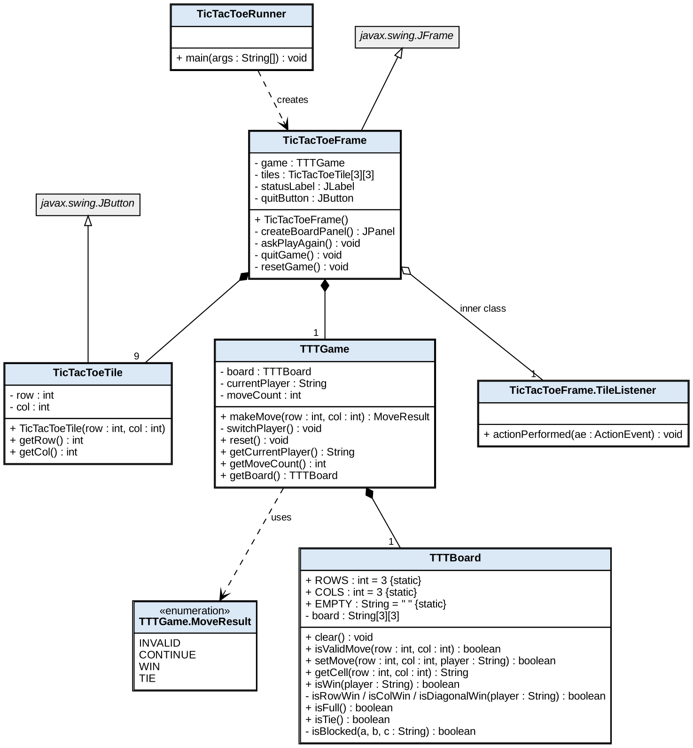
Filled diamond = composition (TicTacToeFrame has 1 TTTGame and 9 TicTacToeTiles; TTTGame has 1 TTTBoard). Hollow diamond = TileListener inner class shared by all tiles. Hollow triangle = inheritance. Dashed arrow = dependency.
- Now if you created UML Use-cases include those here:
(Not Needed for Part B)

- Implement Tic Tac Toe as a Java Swing GUI Project using the new objects that you developed. It should be identical in the interface to the original TTT but now has a better engineered basis.
Project Name: Lab07B_OOPTTT

GitHub Repo:
Paste the GitHub repo link for Lab07B_OOPTTT here.

Run Screenshots
Screenshot 1 — Game Start
Empty board with "Player X's turn" shown.
Insert screenshot here (Game Start). Make sure the taskbar date/time is visible.

Screenshot 2 — Illegal Move
Clicking a square that is already taken shows the Illegal Move warning.
Insert screenshot here (Illegal Move). Make sure the taskbar date/time is visible.

Screenshot 3 — X Wins
A winning row, column, or diagonal with the "Player X wins!" message, then the play again dialog.
Insert screenshot here (X Wins). Make sure the taskbar date/time is visible.

Screenshot 4 — Tie Game
A tied board with the "It's a Tie!" message, then the play again dialog.
Insert screenshot here (Tie Game). Make sure the taskbar date/time is visible.

Code Screenshots
Screenshot 5 — TicTacToeRunner.java
Insert code screenshot of TicTacToeRunner.java here.

Screenshot 6 — TicTacToeFrame.java
Insert code screenshot of TicTacToeFrame.java here.

Screenshot 7 — TTTGame.java
Insert code screenshot of TTTGame.java here.

Screenshot 8 — TTTBoard.java
Insert code screenshot of TTTBoard.java here.

Screenshot 9 — TicTacToeTile.java
Insert code screenshot of TicTacToeTile.java here.

Screenshot 10 — TTTBoardTest.java / TTTGameTest.java (JUnit tests passing)
Insert code screenshot of TTTBoardTest.java / TTTGameTest.java (JUnit tests passing) here.

Use the Canvas Assignment mechanism to submit the link to your GitHub repo for this project and after inserting your screen and code shots this file renamed LastnameFirstname _Lab_07B.docx (using your actual name).

